VySkan
Product Name | 4G LTE Tactical Pet & Hound Tracker
Product Model | VP-Pet
Lightweight. Rugged. Unlosable.
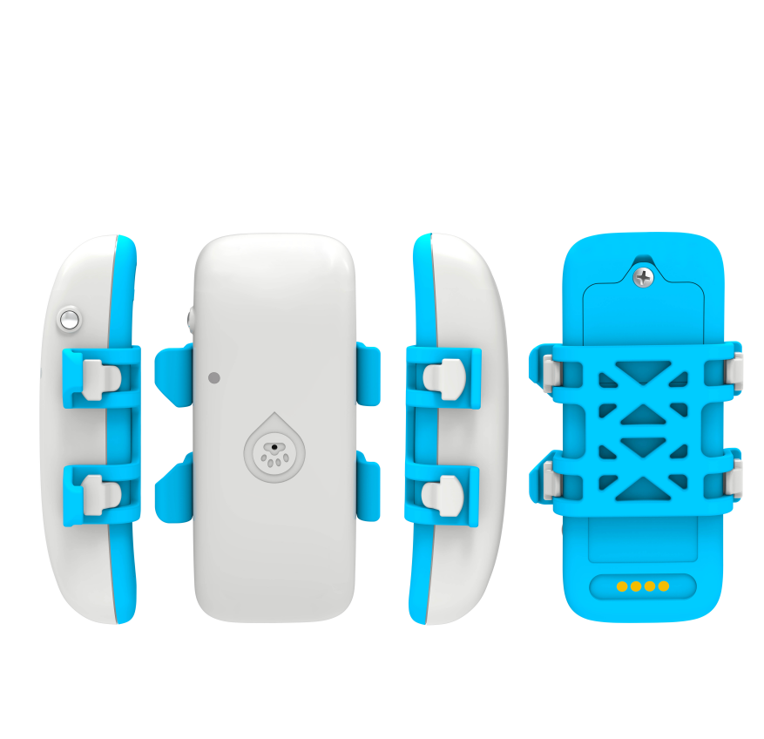
Engineered specifically for high-value pets, working dogs, and outdoor hounds, the Vyskan VP-Pet is an ultra-lightweight 4G LTE positioning terminal that redefines animal tracking. Integrating multi-constellation GNSS (GPS, BDS, GLONASS) with a highly sensitive 3-axis accelerometer, it delivers smart vibration-activated tracking and proactive geofence alerts. Weighing a mere 42.2g and paired with a dedicated silicone collar attachment, it is the ultimate rugged, unobtrusive tracking solution designed to keep animals safe in unpredictable outdoor environments.
- Core Value
- Dynamic Smart Power Management
Driven by a built-in accelerometer, the device seamlessly switches between Continuous, Normal, Power-Saving, and Standby modes based on the animal's activity. This intelligent logic maximizes the 700mAh battery lifespan, drastically reducing the charging frequency for pet owners while ensuring the tracker is fully active when the dog is on the move.
- Active "Sound & Light" Retrieval
Equipped with an integrated buzzer and a high-intensity white LED seeking light. When a dog is lost in dense brush, deep woods, or low-light conditions, owners can trigger a remote audio-visual alarm to rapidly close the crucial "last 50 meters" of the search.
- Zero Data Loss in Blind Spots
A built-in high-capacity memory chip automatically caches offline trajectory data when the animal runs into cellular blind spots (like deep valleys or dense forests). Once the network is restored, the data is seamlessly uploaded to the platform, ensuring a 100% complete movement footprint.

- Target Applications
- Working & Hunting Dogs: (The ultra-lightweight 42.2g body ensures zero physical burden during high-speed chases, while multi-mode tracking captures fast movements).
- High-Value Pet Anti-Theft: (Virtual geofences instantly alert owners if a pet leaves the designated safe zone, providing critical time for recovery).
- Outdoor Pet Adventures: (IP65 dust/water resistance and offline data caching make it perfect for off-grid hiking and trail tracking).
- Technical Specifications
  - Cellular & GNSS
Category | Specification | Description
Network Bands | 4G LTE-FDD & 2G GSM | Broad cellular connectivity (B1/B3/B5/B7/B8/B20) for reliable tracking across vast rural or urban areas.
Positioning Mode | GPS + BDS + GLONASS | Multi-constellation tracking ensures highly accurate visibility, even under heavy forest canopies.
Startup Time | Cold: Avg 32s | Hot: Avg 1s | Rapid Time-To-First-Fix (TTFF) for instant location acquisition the moment the collar is equipped.
Sensitivity | -161 dBm | Maintains a strong satellite lock under challenging outdoor environmental conditions.
  - Power & Electrical
Category | Specification | Description
Battery Capacity | 700mAh(3.7VPolymer) | Optimized internal battery engineered for extended outdoor cycles and smart power conservation.
Working Current | 60mA (Active) @ 4V | Highly efficient power utilization during active high-frequency data transmission.
Standby Current | 5mA (Standby) @ 4V | Ultra-low drain during idle periods (when the pet is resting) to maximize operational longevity.

  - Interfaces & Expandability
Category | Specification | Description
Audio/Visual Output | Buzzer & White LED | Remote-activated sound and light triggers for rapid localized animal recovery.
Sensor | 3-Axis Accelerometer | Enables vibration alarms and intelligent wake-up logic based on the pet's movement.
Data Interface | Magnetic Port + Serial | Secure, easy-to-use magnetic charging that prevents water/mud ingress commonly caused by dogs.
  - Physical & Environmental
Category | Specification | Description
Dimensions | 75.8mm×37.6mm × 19mm | Ultra-compact design that sits comfortably on standard collars without restricting neck movement.
Weight | 42.2g | Exceptionally lightweight, eliminating carrying fatigue for small to large breeds.
IP Rating | IP65 | Resists dust, mud, and low-pressure water jets, ensuring durability for active outdoor dogs.
Operating Temp. | -20℃ to 75℃ | Robust industrial-grade resilience in freezing winter walks or hot summer hikes.
- Deployment & Integration
Unobtrusive Deployment & Seamless Integration: The VP-Pet eliminates complex setups. It comes out-of-the-box with a dedicated silicone collar attachment and a sealed magnetic charging system designed to withstand mud and moisture. It fully supports Over-The-Air (OTA) remote configuration , allowing distributors or end-users to effortlessly adjust reporting intervals, switch tracking modes, or draw virtual electronic fences directly from the mobile APP without physically accessing the collar.
- A personalized service prepared for you
- 1× VP-Pet Sample Device (Pre-configured)
- Full API & Protocol Documentation
- 1-on-1 Technical Support from our Field Engineers
- Contact us
Website: https://vyskan.com/
Email: marketing@vyskan.com

